Name: Antonio Scalfaro  
Date: 1/23/2024  
Week: 2 - Create an Analysis Model for a Small Bed & Breakfast Reservation System

1)  
Rubric Criteria:  
Create UML use case diagram of 3-7 use cases 10%  
Your Response:

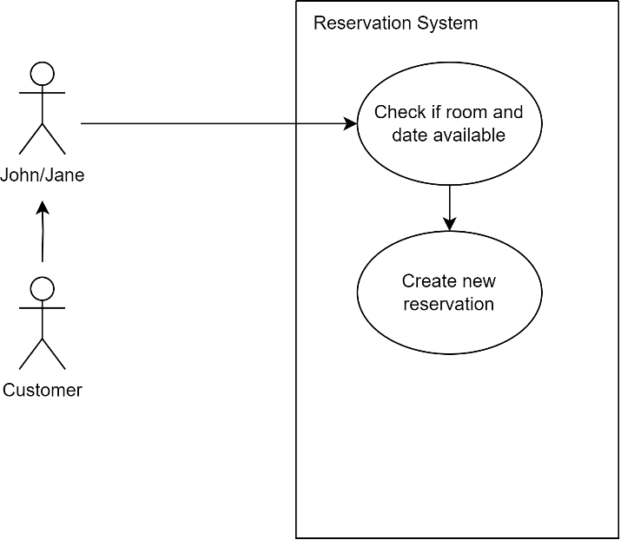

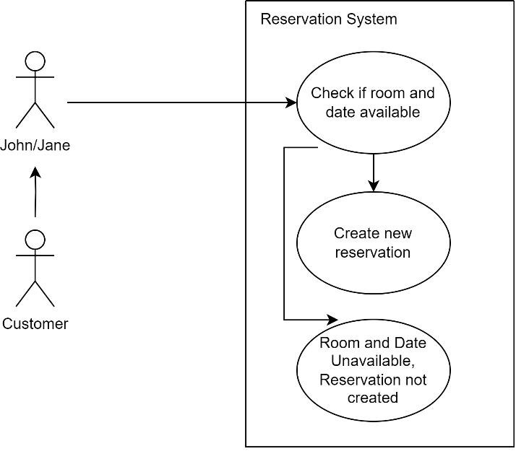

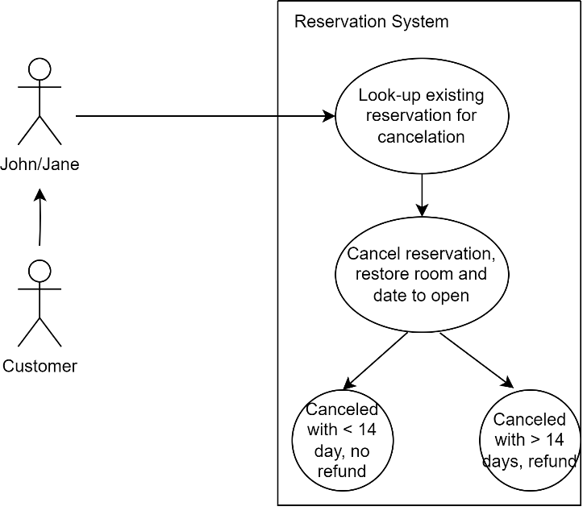

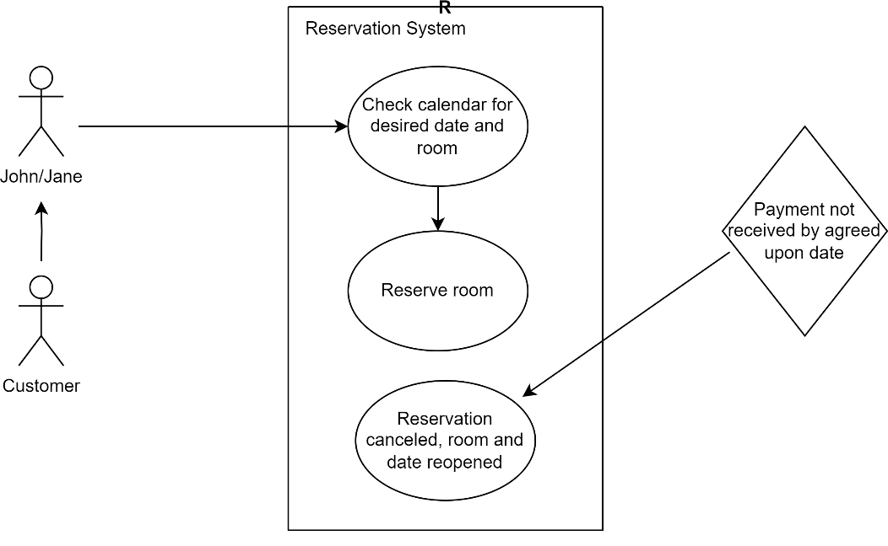

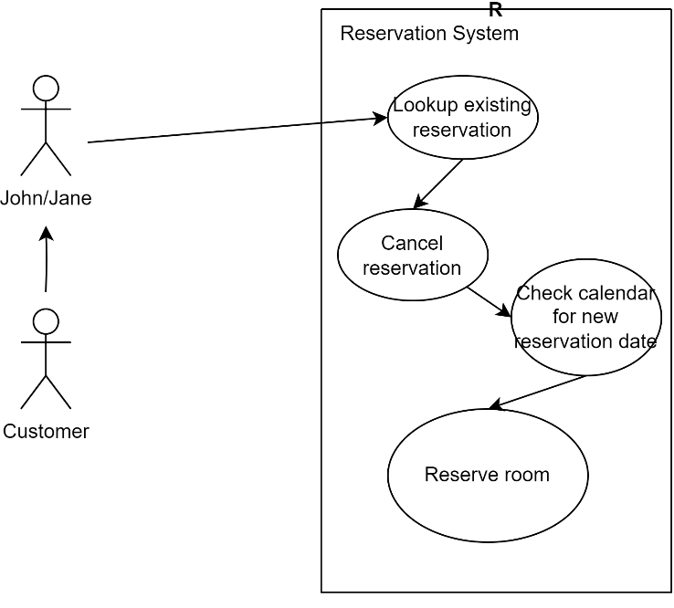

2)  
Rubric Criteria:  
Write use case sequence of events for each use case in the use case diagram 20%  
Your Response:

1. Reserve a Room
   1. Customer calls John/Jane
   2. John/Jane check system for room and date availability
   3. Reserve room
2. Reserve a Room (Unavailable date/room)
   1. Customer calls John/Jane
   2. John/Jane check system for room and date availability
   3. If room or date unavailable, reservation not made
3. Reservation Cancellation
   1. Customer calls John/Jane
   2. John/Jane lookup existing customer reservation
   3. Cancel existing reservation
   4. If cancellation done with 14 or more days, refund sent
   5. If cancellation 13 days or less, no refund
4. Reservation Cancelled Due to Lack of Down Payment
   1. Customer calls John/Jane
   2. John/Jane check system for room and date availability
   3. Reserve Room
   4. Payment not received by agreed upon due date
   5. John/Jane cancel reservation for lack of payment, room and date now available again
5. Change Reservation date
   1. Customer calls John/Jane
   2. John/Jane lookup existing reservation
   3. Cancel reservation
   4. Check system for new room and date availability
   5. Reserve room for new date and room

3)  
Rubric Criteria:  
Explain approach, steps, and rationale of the use case model 25%  
Your Response:

My approach was to give a broad overview of potential cases in which John and Jane may use their new reservation system. I chose to include a simple reservation, a call for a reservation for a date and room that was already booked, a reservation cancellation, a reservation cancellation due to lack of down payment, and a change in reservation. These are five cases that would be expected use cases for the reservation system John and Jane requested. I tried to think of ‘edge case’ uses of the system while crafting four of the five cases, with the fifth one being the basic reservation which would be expected often.

4)  
Rubric Criteria:  
Create UML class diagram 10%  
Your Response:

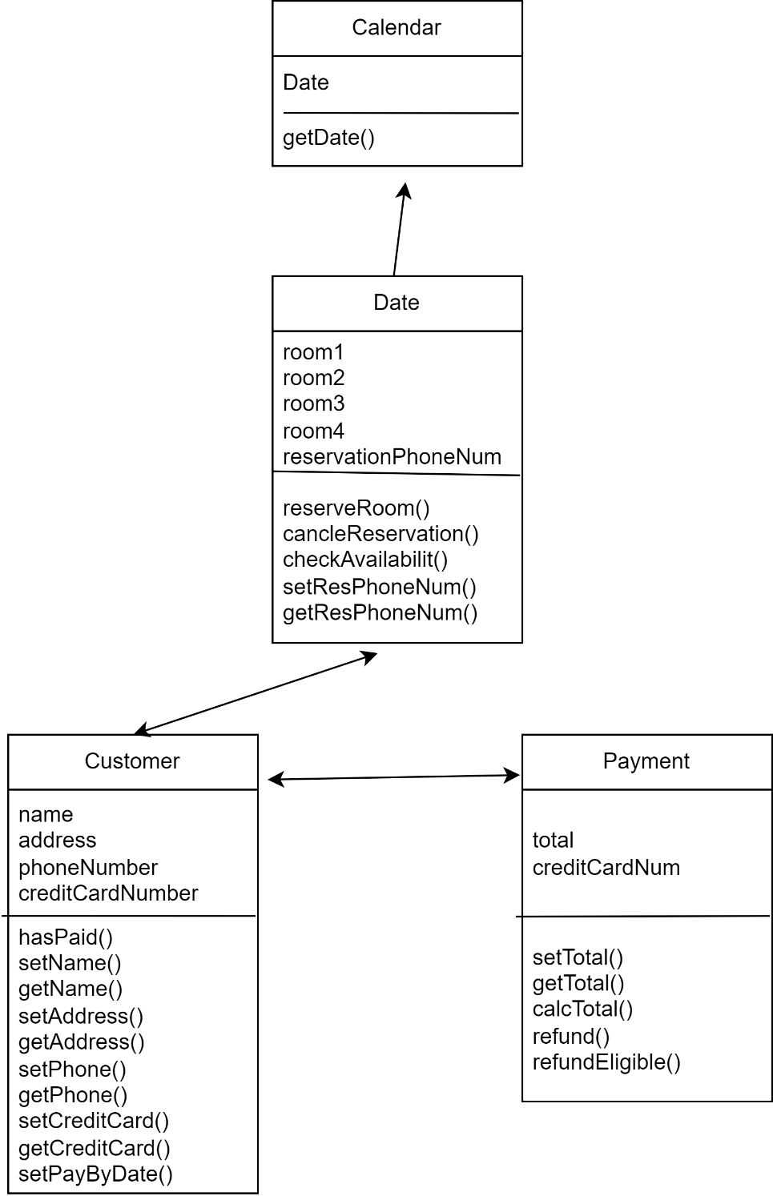

5)  
Rubric Criteria:  
Explain approach, steps, and rationale of the class diagram model 25%  
Your Response:

While creating the class diagram I tried to think of as many classes and variables as possible that could be needed for the reservation system. I settled on a base structure of four classes, Calendar, Date, Customer, and Payment. The Calendar class is at the top of the structure because it is the starting point for any reservation. It uses an instances of the Date class for every date so that every date has the unique properties of the Date class. The Date class will be able to check for availability and reserve rooms under the customer phone number, which is how I would imagine each reservation could be looked up. The Customer class has all the pertinent information for each customer with associated getters and setters. It also has a function to set the Pay By date. The Payment class calculates the total and charges to the credit card of the customer. If a cancellation is made, the Payment class can check if a refund is eligible and make the refund if that is the case.

6)  
Rubric Criteria:  
Reflect on the learning experience and lessons learned 10%  
Your Response:

This was a much tougher assignment than I had originally given it credit for. Trying to plan these types of systems feels like pulling something out of thin air. I wrote down all the data that would be needed, then wrote them into classes, then pictured how the classes would interact with each other. I wrote down the class structure and then built the class diagram. Even then, I found I was adding as I created it. I feel like the UML use case diagram and the class diagram could be significantly upgraded but for my first time, I will accept what I have created. In time and with practice, I will be better. I learned that there will be much more under the hood of any given system, even simple ones. I had fun creating this and learning along the way.